Report on NAT Test Automation Framework

Contents
1. Introduction About NAT Test Automation Framework 5
1.1 Tools/Technology Used for NAT Test Automation Framework 5
1.1.1 Frontend (Functional) 5
1.1.2 Rest API Based Services 5
1.1.3 Design Continuous Testing Model 5
2. Overview of NAT Test Automation Framework 6
3. Architecture of NAT Test Automation Framework 8
4. Workflow of NAT Test Automation Framework 9
5. Script flow of NAT Test Automation Framework 11
6. Roadmap 12

No table of figures entries found.

Executive Summary

NAT Test Automation Framework is developed to support the execution of weekly regression tests, scenario-based tests, and user story verification. This framework helps in testing web-based application and restful web services.
The framework is a hybrid model, and its core design is based on Serenity BDD framework with core JAVA used as programming language. The framework design and architecture support CI/CD by default.
At present, NAT Test Automation Framework includes & executes test cases for 53 user-stories. The user-stories includes 328 functional and 39 restful webservice test cases.
The tests are designed using Cucumber BDD framework in plain English text called as Gherkin and is the entry point of the framework. The framework supports both Gradle and Maven as build management tool and test execution engine.
The test cases are further isolated through Junit annotations and Cucumber Tags which helps framework to execute a certain test case or group of test cases. As the framework supports CI/CD, a workflow has been designed in GitHub Actions to trigger the scenarios both manually, automatically and via scheduler.
NAT Test Automation Framework also consumes a Webhook created in GitHub Actions which enables and extends the execution of these tests in other GitHub action workflow and process. This feature helps to directly integrate and execute the test inside the NAT Test Automation Framework with any development workflow.
The test environment for NAT Test Automation Framework is docker based and have no dependency on any specific system to execute the tests. The GitHub actions workflow automatically pull the latest docker image and then triggers the test execution.
The entire source code and test cases are stored on cloud-based version of GitHub hence, making it accessible from anywhere.
Regression tests are scheduled for every Saturday evening and get triggered automatically through GitHub actions workflow. With the current list of tests available, to execute the regression tests for functional scenarios execution time is 1 hour and for restful web services execution time is 5 minutes.
Verification of user-stories is triggered through AWS Infrastructure Manager (dashboard which lists all the User Stories in development) through Webhook. For user story verification same set of tests get executed which were triggered during regression testing.
Scenario based testing can be triggered manually from the GitHub web page and needs to provide a cucumber tag of a specific test or group of tests.
NAT Test Automation Framework maintains and stores all the test artifacts on cloud storage provide by AWS. There is an online dashboard through which all the test artifacts are accessible. Additionally, when verification of user-story completes a test summary along with the links of the test reports are logged on JIRA against the ID of user-story verified.

Current Regression Test Summary is as below:
Engineering  Tools | Total Requirements | Total Number of Test Cases | Requirements Automated | No of Test Cases Automated | No of Test cases Not Automated | Test Automation % | Test Coverage %

Introduction About NAT Test Automation Framework

NAT Platform Services is a web-based application developed using technologies like React, AXON Server, Java, HTML5, Spring Boot and AWS.
QA team of Platform Services developed NAT Test Automation Framework which uses latest technologies & frameworks to test and automate these web services and web applications.
This is an agile based development and follows Continuous Integration, Testing and Deployment. Hence, deployment, testing and release are automated processes.
Team has designed build, test and deployment systems which performs Continuous Integration, Continuous Testing and Continuous Deployment automatically.

Tools/Technology Used for NAT Test Automation Framework

QA Team of NAT Platform Services uses latest technologies and framework to design and test the product. To automate different Test Automation types, QA team have identified various tools and frameworks which is highly ranked and valued as per current market trends.

Frontend (Functional)
- Selenium
- Serenity BDD with Screenplay
- Cucumber
- Java
- Gradle
- Maven

Rest API Based Services
- Rest Assured
- Serenity BDD with Screenplay
- Cucumber
- Java
- Gradle
- Maven

Design Continuous Testing Model
- Git Hub Actions
- JavaScript
- NodeJS
- Docker
- AWS

Overview of NAT Test Automation Framework
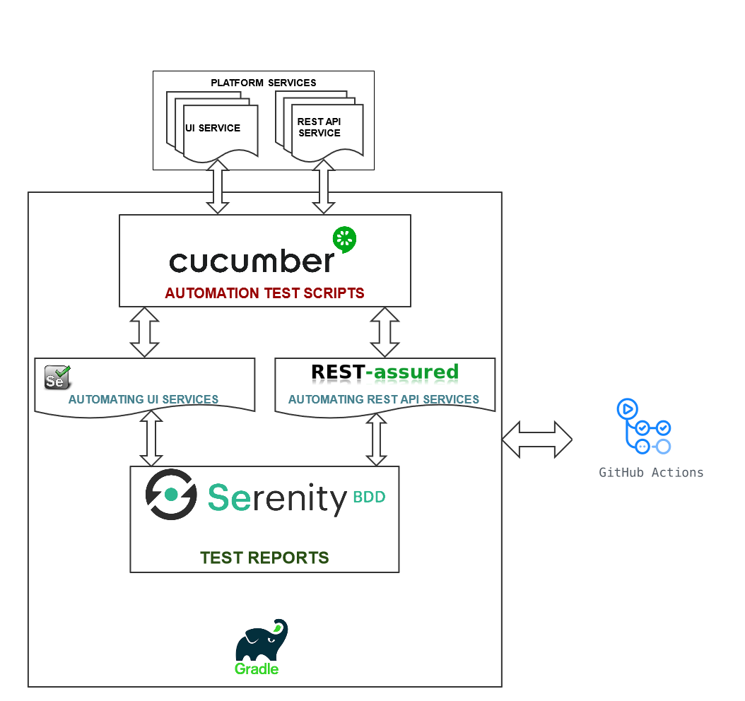

The above model displays explain the functional test automation high level architecture.
FUNCTIONAL TESTING is a type of software testing that validates the software system against the functional requirements/specifications. The purpose of Functional tests is to test each function of the software application, by providing appropriate input, verifying the output against the Functional requirements.

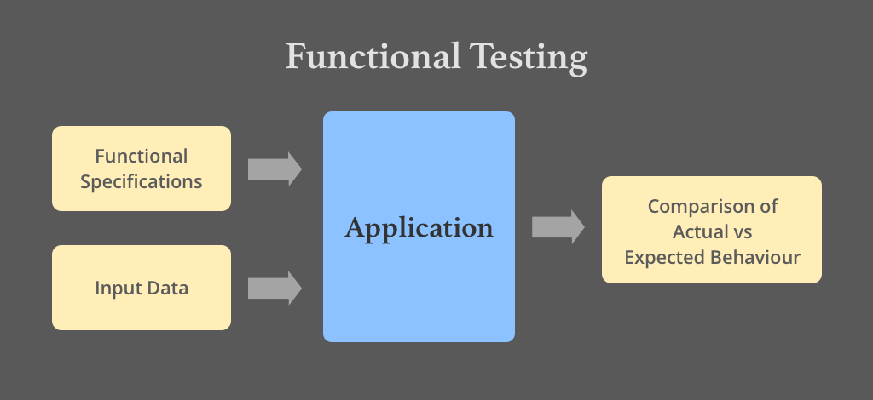

Now referring to our original functional test automation architecture, under functional test we verify two major application types

- Web User Interface – Verification of dynamic/static functionalities implemented through the User Interface.

- Rest based Web API – These API act as an interface between backend and frontend. Here we basically verify the data received (provided by the backend through these API)

Functional tests are written and maintained in Gherkin language, for which we are using a tool called Cucumber. As per Gherkin standards, each requirement is covered as a feature and every feature contains multiple scenarios and user data.
The steps defined in feature file is mapped with a java class, and this java class will refer the required objects (frontend elements) and libraries (front-end and rest api)
Serenity is as a BDD based test-automation framework which is used to test both frontend and Rest API. Serenity automatically collects the test data and creates a HTML based test-report.
Gradle is a driver which triggers these tests by calling a java based main() class.
The main() class initializes & executes the tests and creates the test-report.
As a part of CI/CD initiative, GIT-HUB Action will automatically trigger these tests, collects the test-artifact and copies them on the AWS.

Architecture of NAT Test Automation Framework

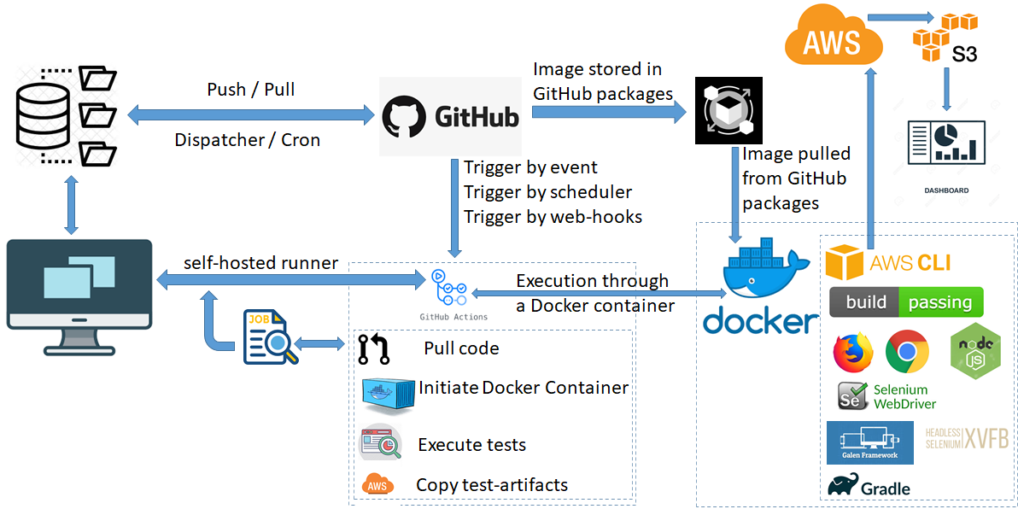

The above model explains the test automation architecture designed for Platform Services.

QA team maintains the test automation framework code and test scripts in repository maintained in GitHub.

GitHub also stores a test infrastructure docker image under GitHub package.

The docker image contains the required test environment (browsers, frameworks, libraries, and build & test engine) to launch and perform automated testing.

The repository contains a workflow which is called by GitHub to trigger the set of actions defined under the workflow.

In case of Platform Services once the workflow is triggered:

- The latest code is triggered
- Docker Container is Initialized
- Tests are executed
- Test Artifacts generated during execution are copied to AWS

A test system needs to associate with a workflow which can be either a Virtual system hosted at GitHub / AWS or it can be a local hosted system connected with GitHub through Self-Hosted Runner.

Self-Hosted Runner is a GitHub Service which needs to be configured on the system required to be connected with GitHub. When the service is running on the system GitHub can identify the system and can perform the execution of the workflow on it.

Workflow of NAT Test Automation Framework

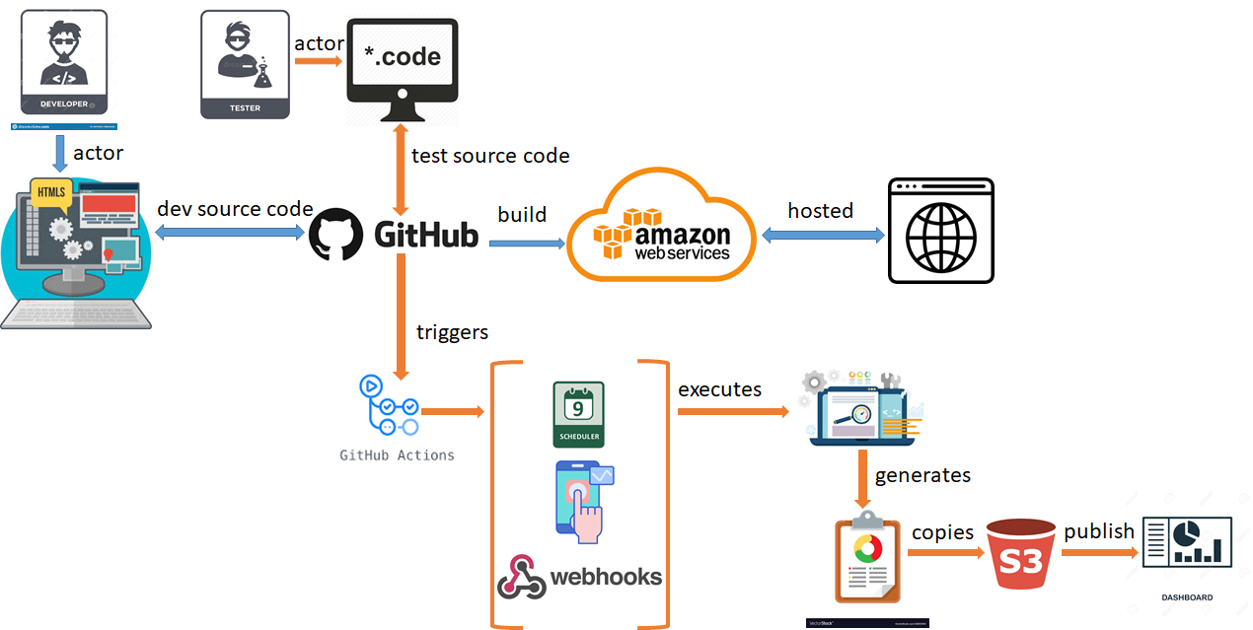

The above model explains the workflow of test automation when QA team develops and integrates the automated test-scripts with the framework.

Test Automation can be triggered by 3 ways:

- Manually: This is an on-demand approach where any member from QA / Developer can manually trigger the test-automation by clicking the <Run workflow> from the GitHub Actions.

- Scheduler: This is a scheduled approach where workflow will get triggered automatically at a scheduled day and time.

- Webhooks: This is also an on-demand approach but more in lines with Continuous Testing and Integration approach. Webhooks are customizable GitHub action rest API which user can integrate with its workflow to trigger an external workflow. This means a developer can integrate a Webhook in its workflow process. Once the code is developed, compiled, build and successfully deployed, the development workflow can trigger the test-automation workflow. If the tests are successful, then code will get merged with Master branch else a defect will get raised and merging of code in Master branch will not happen.

Developer develops the code and merge it in the repository hosted at GitHub. This code gets compiled, build, and deployed in AWS.

QA team develops the test-scripts and merge it in the repository hosted at GitHub. Same repository also maintains the Test Automation Framework code.

GitHub contains a tool known with a name GitHub action. This tool is used to automate the build, deploy, and test processes. To automate a process through GitHub action, GitHub repository should be configured with a Workflow. Workflow defines Step and every Step is associated with some desired action.

A screenshot of an executed GitHub action workflow for reference has been provided. This will show you the execution flow of Steps with desired Actions designed inside the workflow.

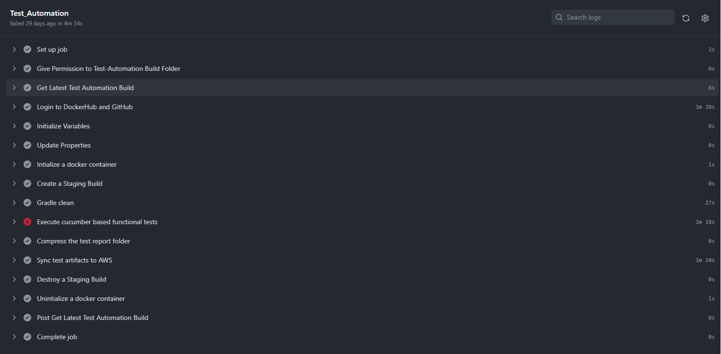
GitHub Action triggers the functional tests -> Generates the Test Artifacts -> Copies the Test Artifacts to AWS -> Publish the Test Data for Dashboard

A screenshot of Dashboard has been provided for reference. The Dashboard publish test data for all the NAT projects which also includes Platform Services.
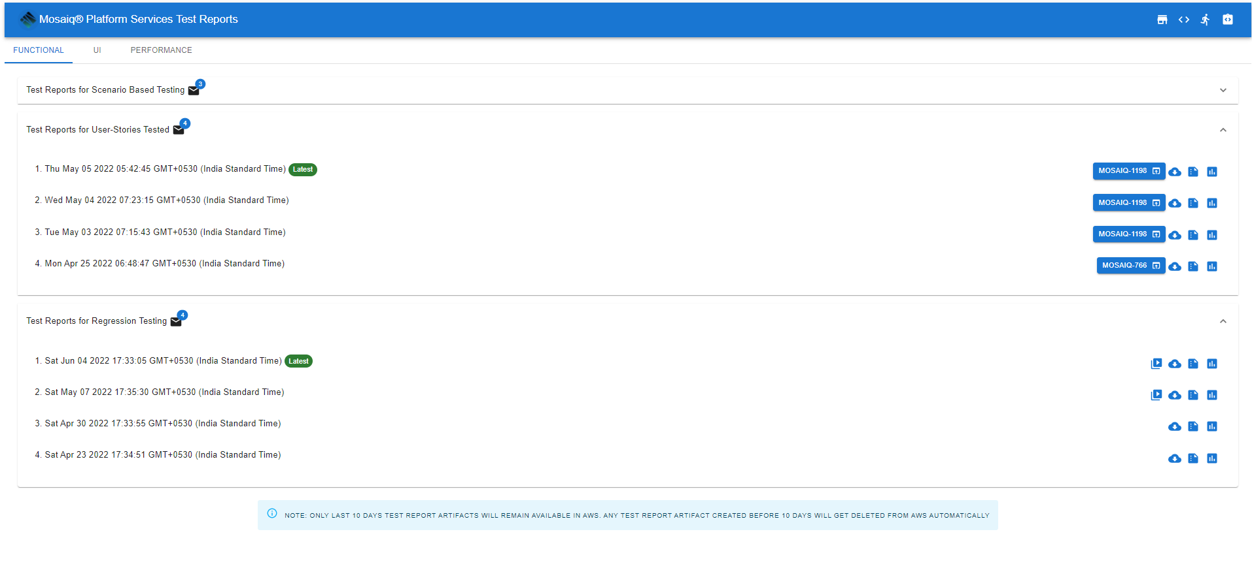

Script flow of NAT Test Automation Framework

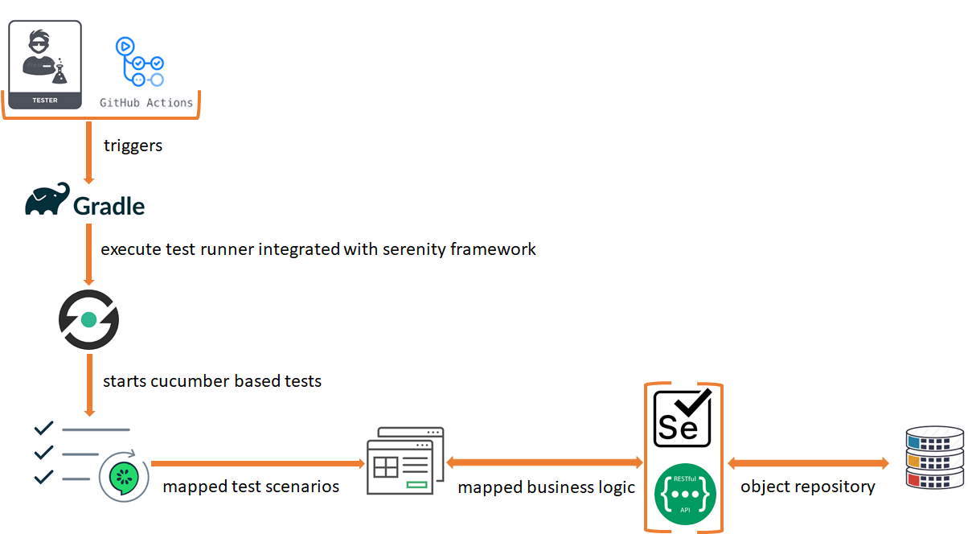

The above model explains the execution flow of functional automated test-scripts once triggered by Github Action.

Gradle is a test engine which triggers the main / test runner class from the framework. The runner class will initialize the Cucumber based feature file. Each feature file will be mapped with its relevant java class which maps defined test steps in cucumber with its relevant java function. Every mapped java class will refer business logic and object repositories.

The mapped java classes are not tightly coupled with each feature file. In fact, these mapped java classes are loosely coupled and can get mapped with multiple feature files hence, making it flexible and shareable.

Same execution model is applicable to perform the frontend (functional) and rest API testing. Such approach gives QA team flexibility to either develop test scripts only for frontend requirements (functional) or rest API using the same framework. Additionally, QA team can develop test scripts which can combine frontend requirements (functional) and rest API.

The test report generated will combine the results of both frontend (functional) and rest API.

Roadmap

QA team will keep extending the test coverage of Functional Automated Test-Scripts. But there are other exciting things that will be developed, Integrated, and deployed.

- Introduction of Performance requirements
- Introduction to Selenium grid
- Development of Automated Performance test-scripts using Taurus along with JMeter Framework
- Integration of Selenium grid with test environment docker image

